/Users/andresmejia/Desktop/Homeworks/blockchain-homework/AM_Network

**Node1:**

**geth account new --datadir node1**

**Pswd:** node1pswd

**Public Address:** **0x1B65f58873803e8d12E2E1bF2989FDAd071Af799**

**Path of the secret key file:** node1/keystore/UTC--2020-04-21T04-08-42.804293000Z--1b65f58873803e8d12e2e1bf2989fdad071af799

**Node2:**

**geth account new --datadir node2**

**Pswd:** node2pswd

**Public Address:** **0x733Fa57D0853f3839525C0A5000627cB2FB7c782**

**Path of the secret key file:** node2/keystore/UTC--2020-04-21T04-09-27.759705000Z--733fa57d0853f3839525c0a5000627cb2fb7c782

**Network:**

**amnetwork**

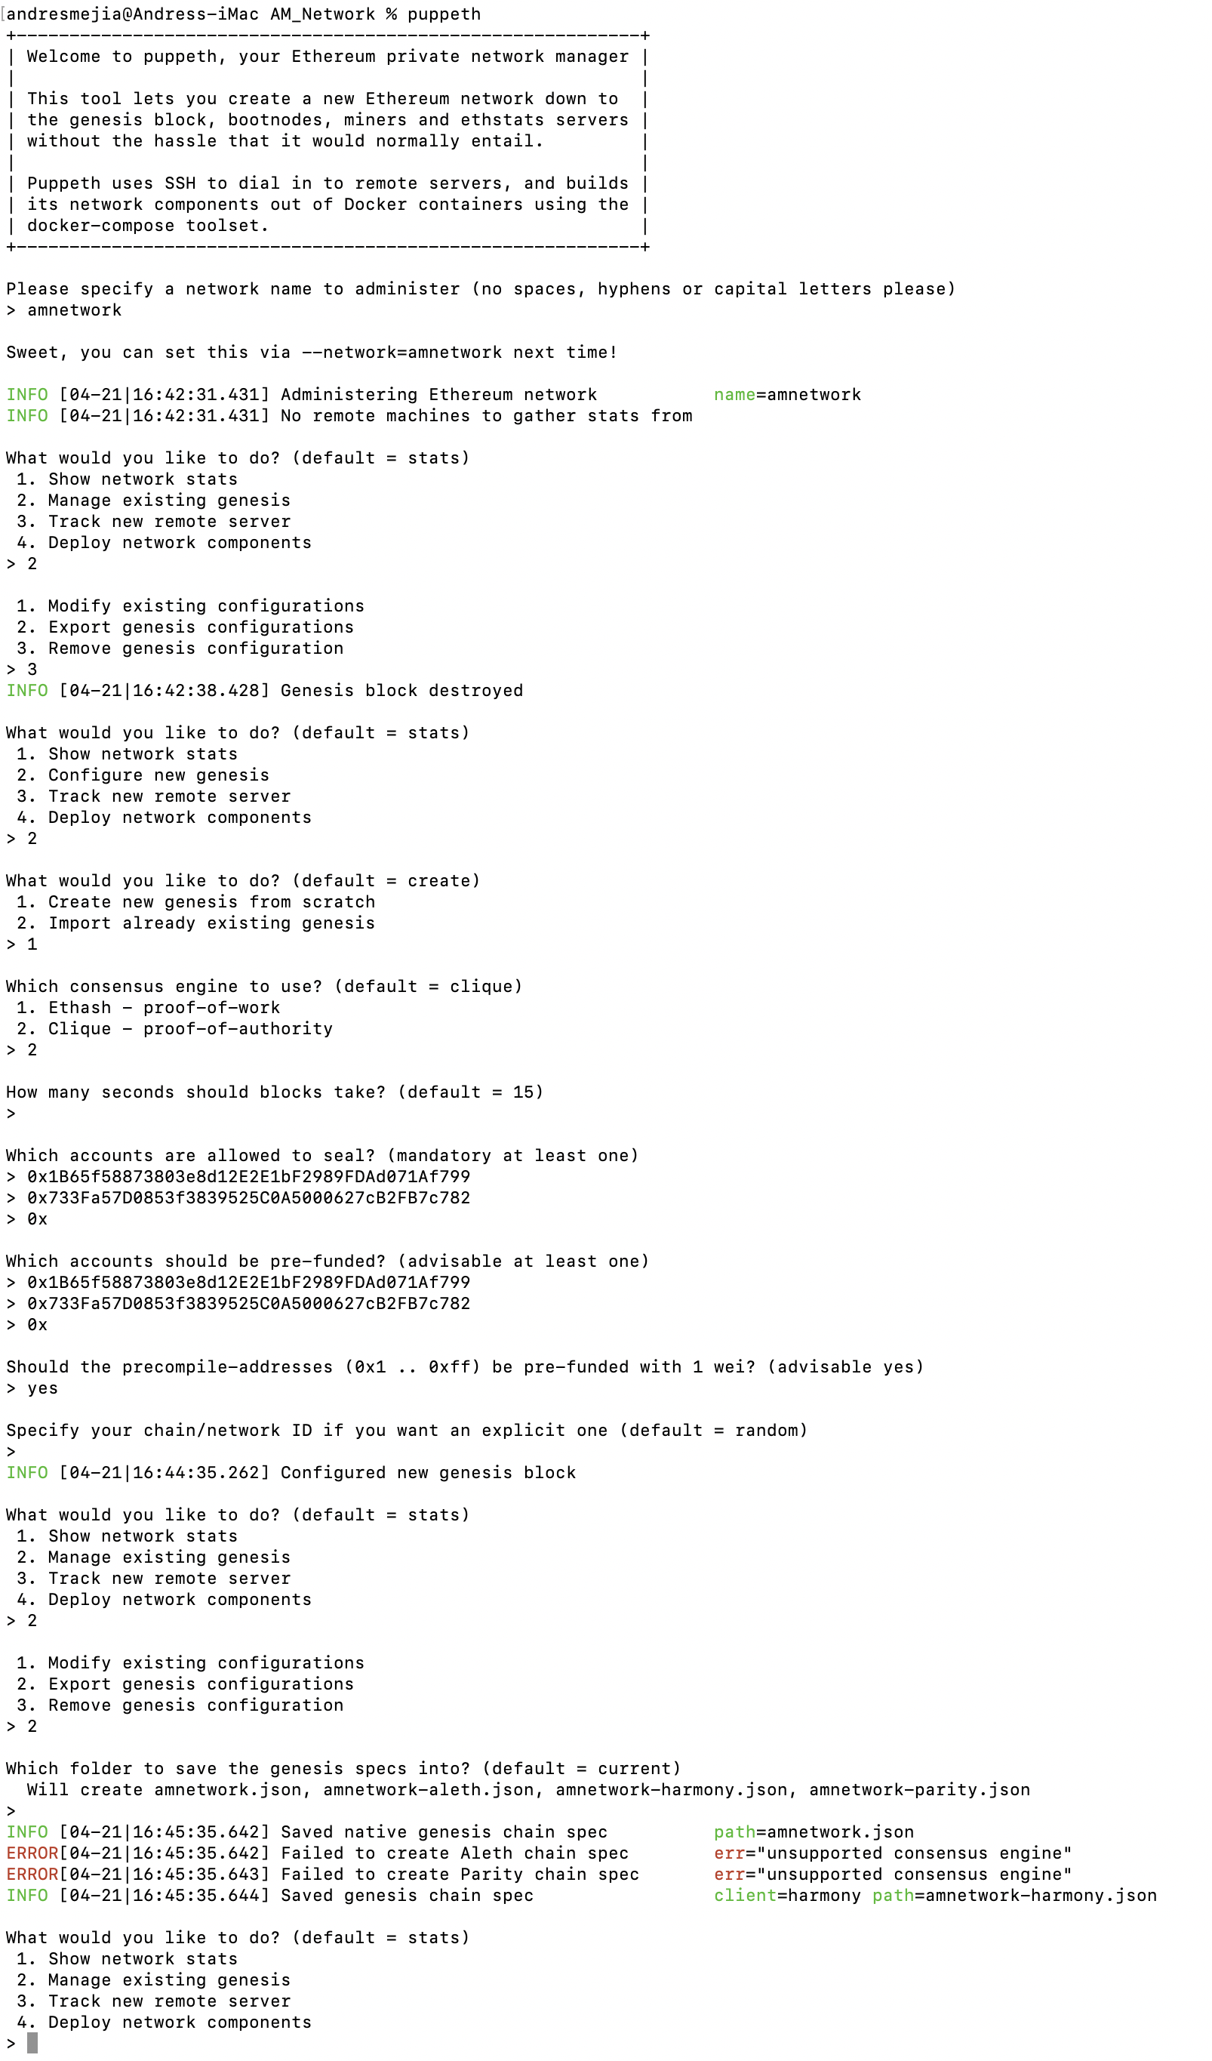

In a separate Terminal Window, in the AM_Network directory:

**geth init amnetwork.json --datadir node1**

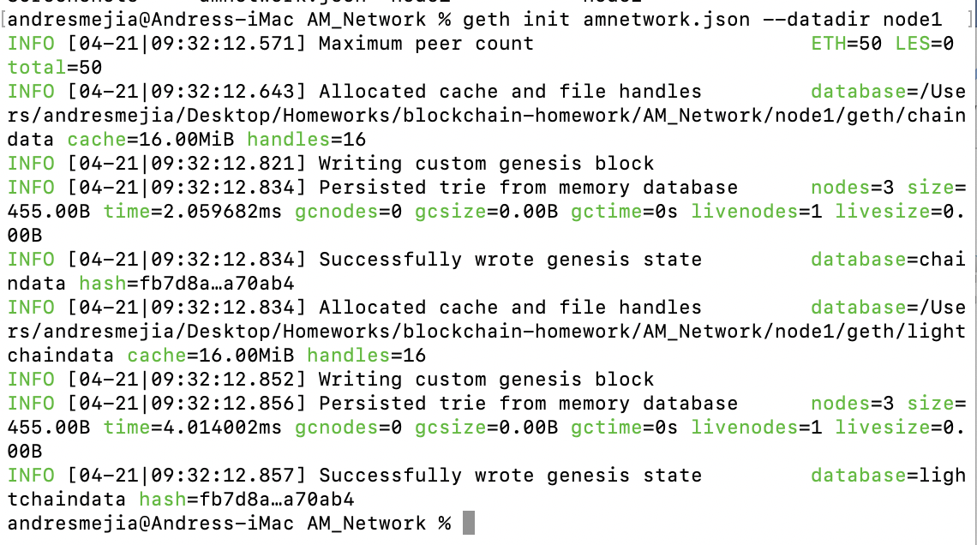

**geth init amnetwork.json --datadir node2**

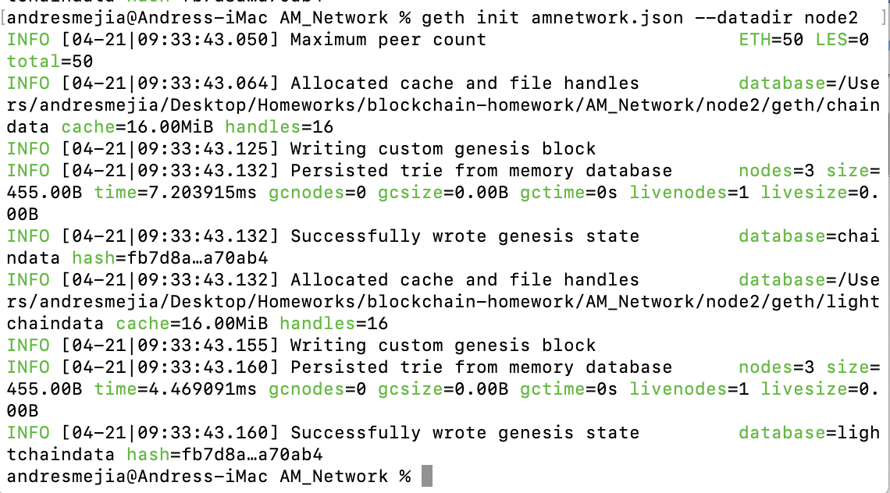

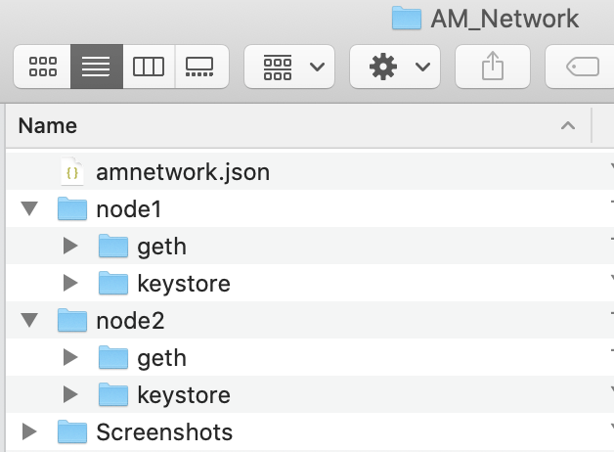

geth --datadir node1 --mine --minerthreads 1 --unlock 0x1B65f58873803e8d12E2E1bF2989FDAd071Af799

Then password: node1pswd

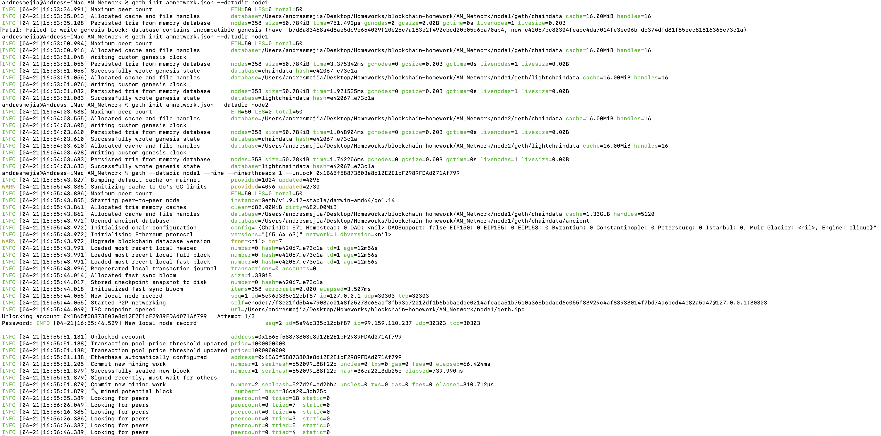

enode://f3e21fd5b447903ac0148f25273c66acf3fb93c72012df1b6bcbaedce0214afeaca51b7510a365bcdaed6c055f83929c4af83933014f7bd74a6bcd44e82a5a47@127.0.0.1:30303

geth --datadir node2 --port 30304 --rpc --mine --minerthreads 1 --bootnodes " enode://f3e21fd5b447903ac0148f25273c66acf3fb93c72012df1b6bcbaedce0214afeaca51b7510a365bcdaed6c055f83929c4af83933014f7bd74a6bcd44e82a5a47@127.0.0.1:30303"

--unlock “0x733Fa57D0853f3839525C0A5000627cB2FB7c782”

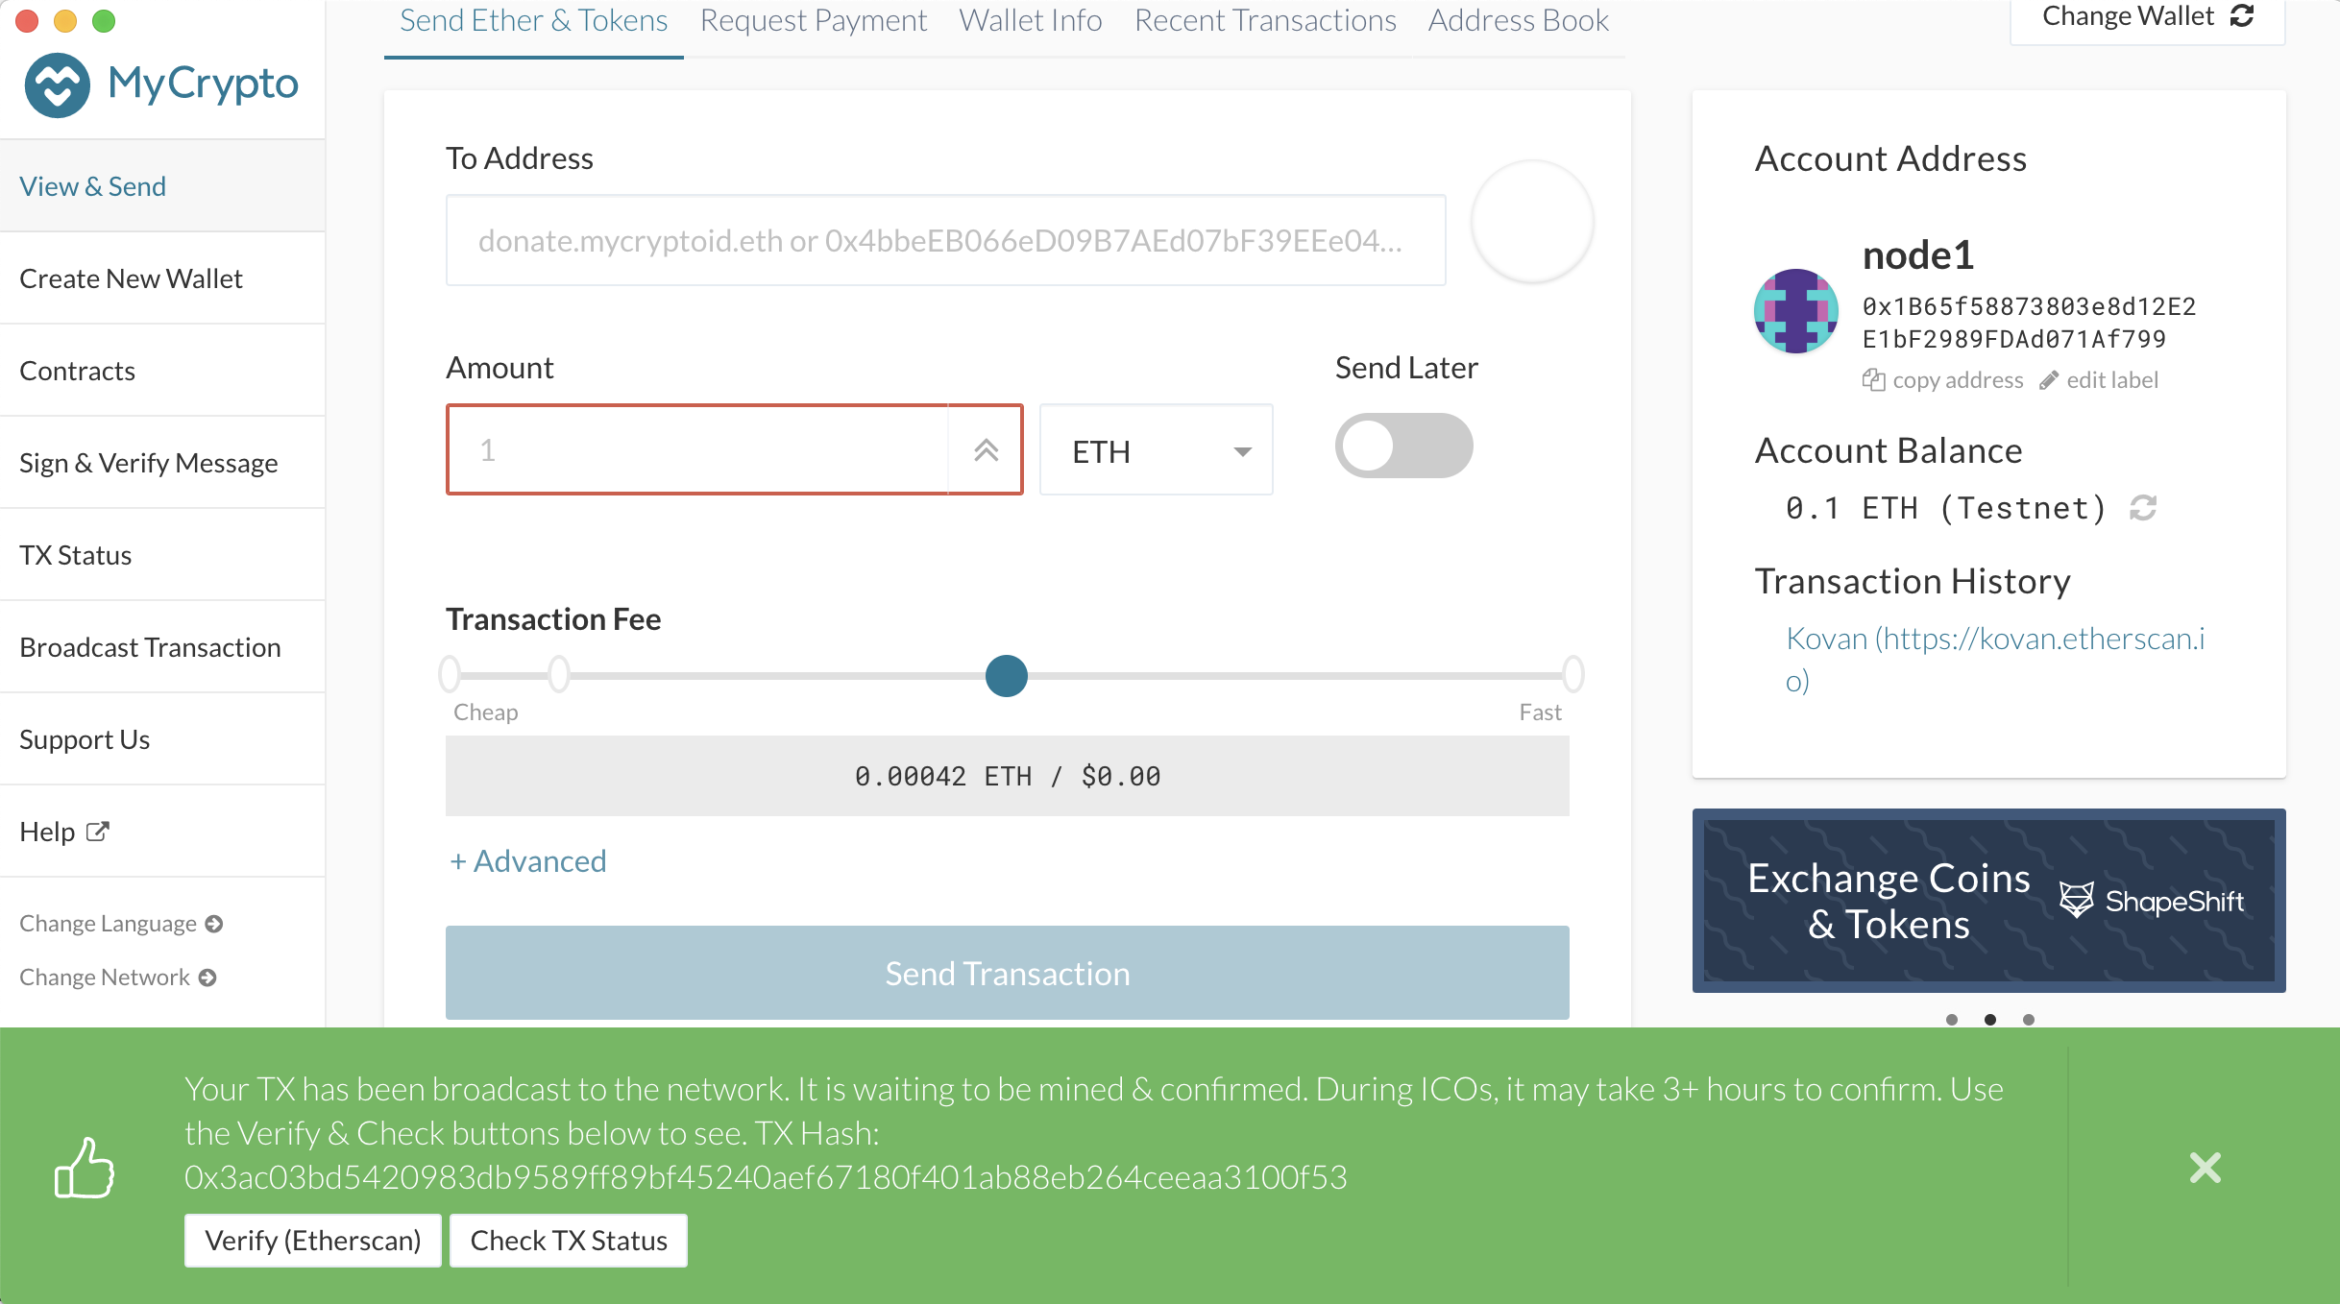

TX Hash:0x3ac03bd5420983db9589ff89bf45240aef67180f401ab88eb264ceeaa3100f53

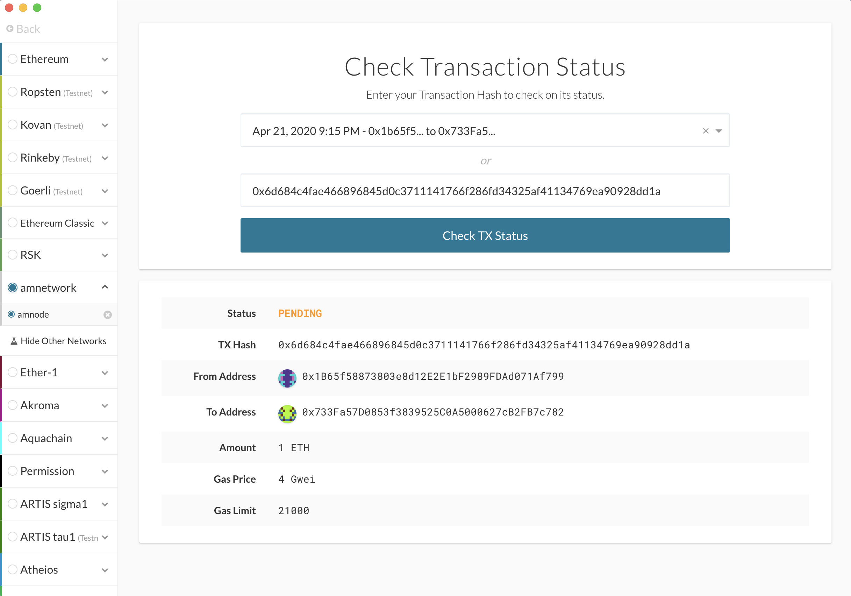

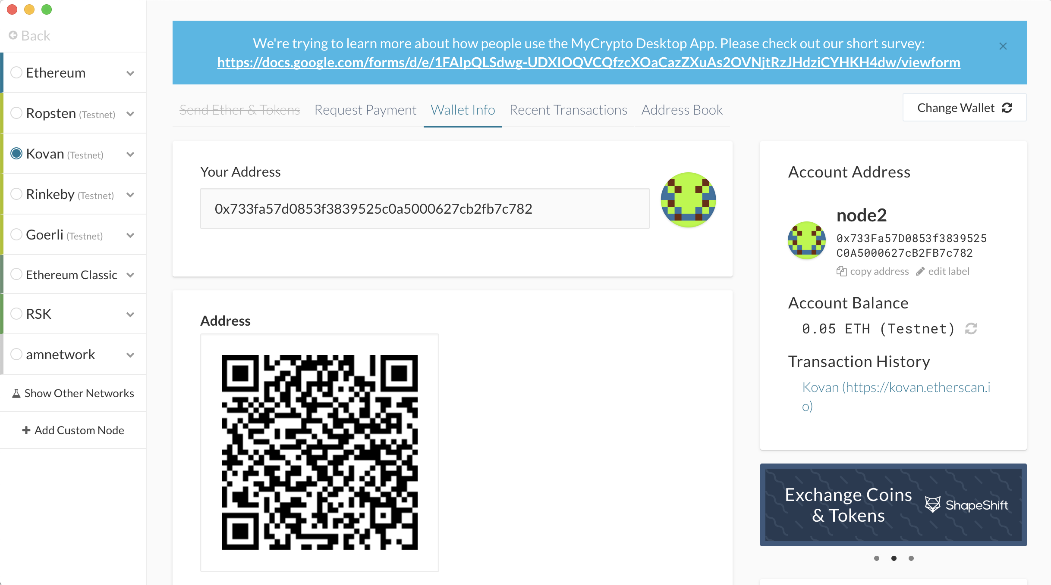

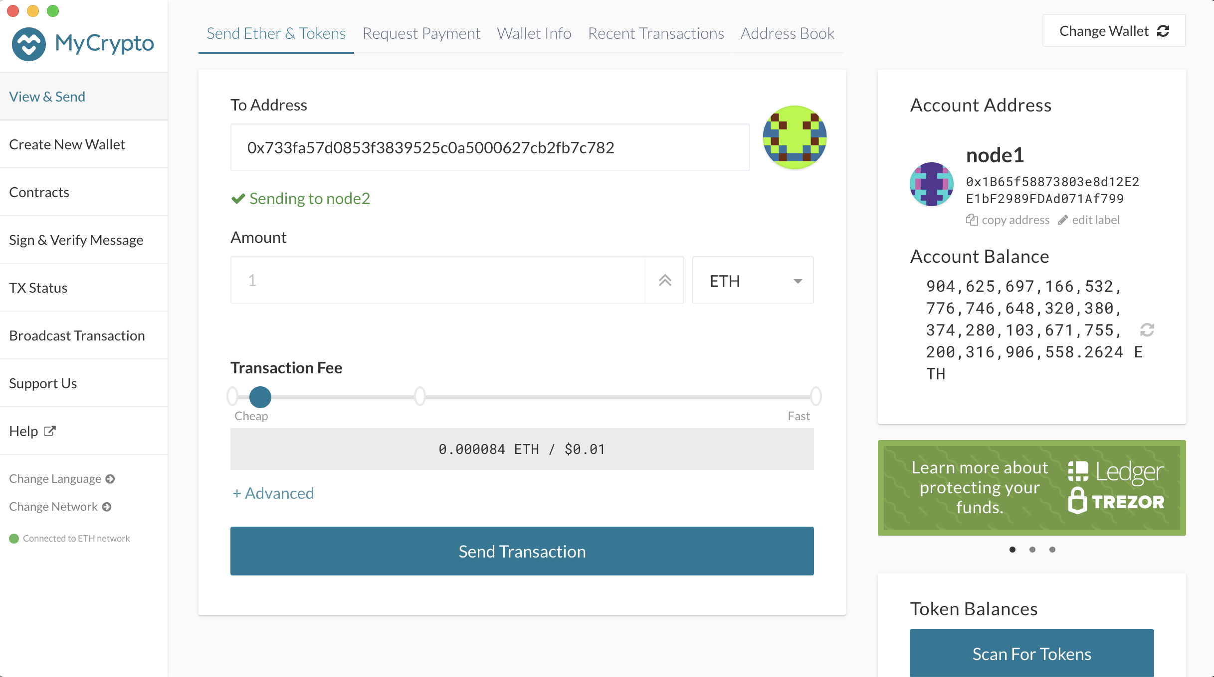

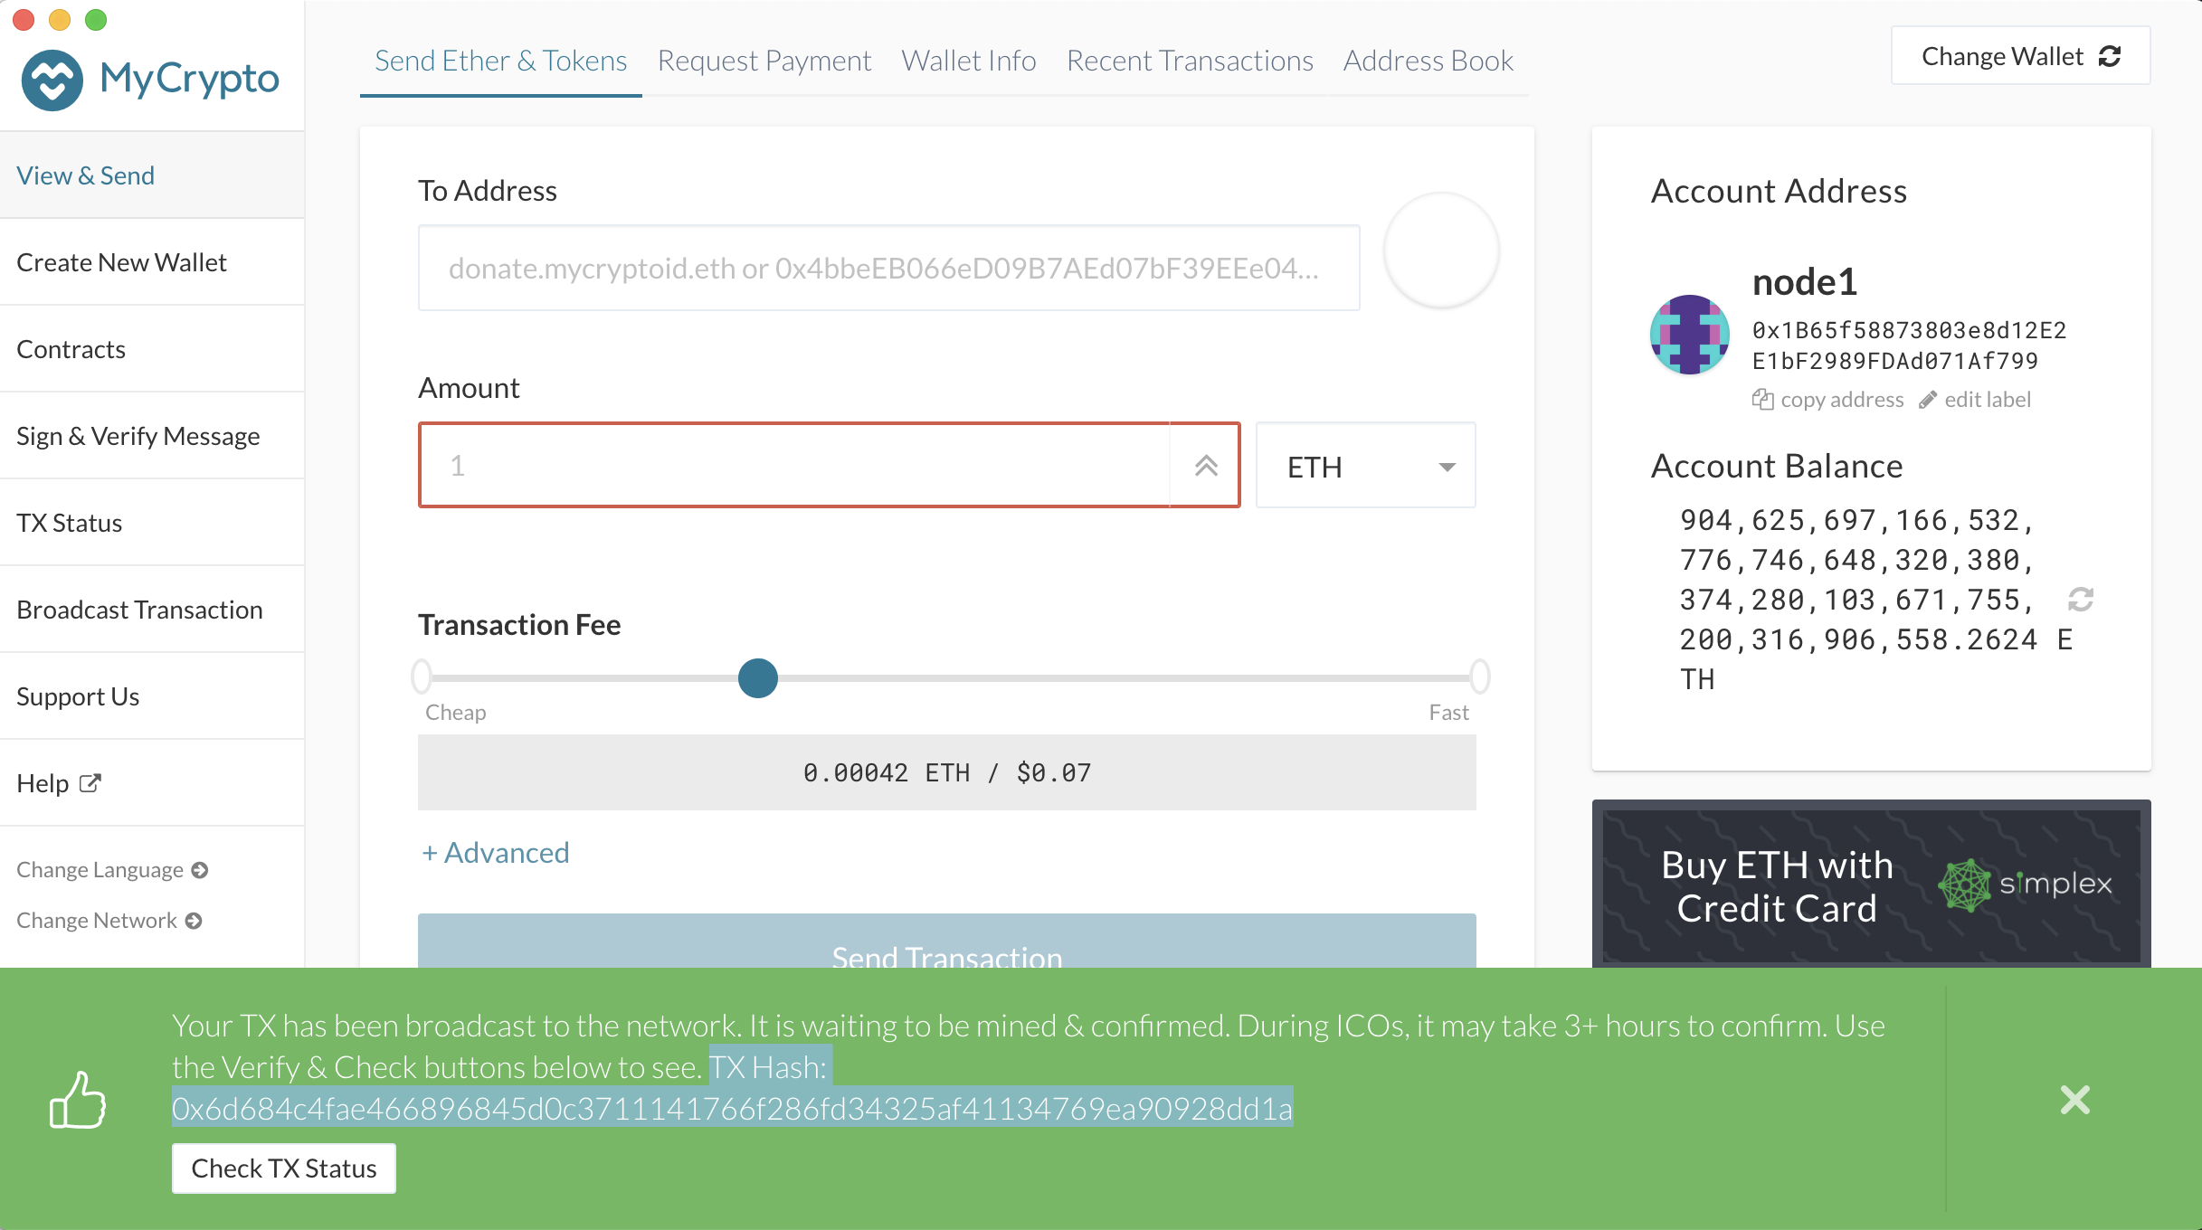

TX Hash:0x6d684c4fae466896845d0c3711141766f286fd34325af41134769ea90928dd1a